Practical 5
Connecting Camera and capturing Images
Camera
The Raspberry Pi camera module can be used to take high-definition video, as well as stills photographs. It’s easy to use for beginners, but has plenty to offer advanced users if you’re looking to expand your knowledge. There are lots of examples online of people using it for time-lapse, slow-motion and other video cleverness. You can also use the libraries we bundle with the camera to create effects.
If you’re interested in the nitty-gritty, you’ll want to know that the module has a five megapixel fixed-focus camera that supports 1080p30, 720p60 and VGA90 video modes, as well as stills capture. It attaches via a 15cm ribbon cable to the CSI port on the Raspberry Pi. It can be accessed through the MMAL and V4L APIs, and there are numerous third-party libraries built for it, including the Picamera Python library.
The camera module is very popular in home security applications, and in wildlife camera traps. Take snapshots from the camera.
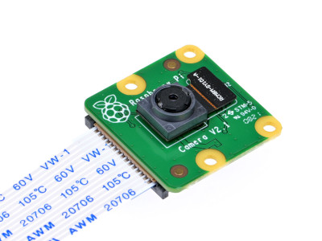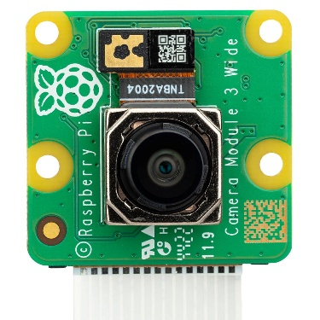
Features
- 5MP sensor
- Wider image, capable of 2592x1944 stills, 1080p30 video
- 1080p video supported
- Size: 25 x 20 x 9 mm

Installation
Installation involves connecting the ribbon cable to the CSI connector on the Raspberry Pi board.

Enable the camera interface
- Open terminal and type sudo raspi-config
- Write the steps of the practical performed with the screen shots
- Click a photo and put as the output
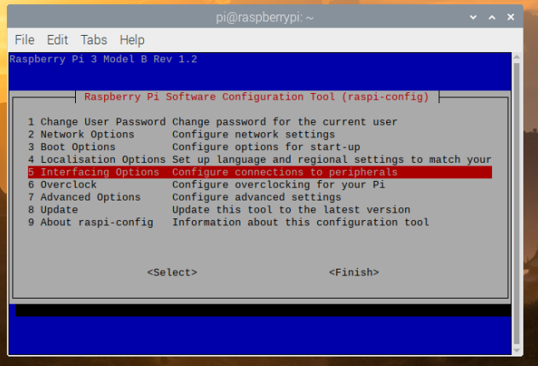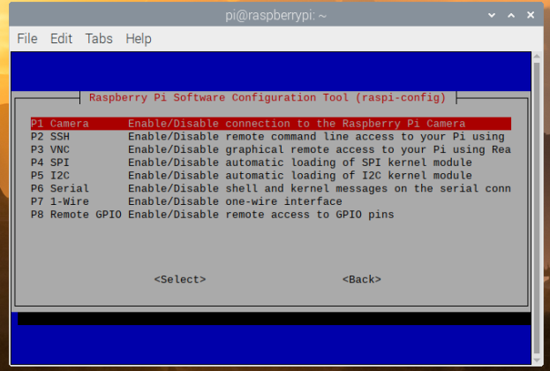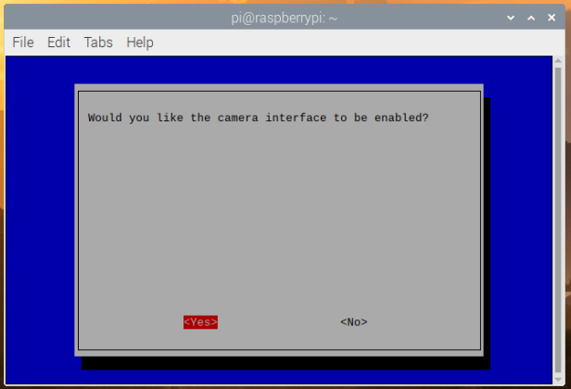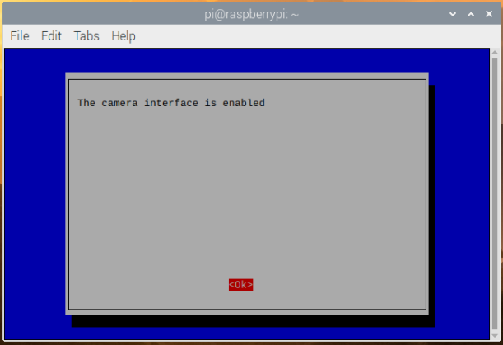

Code: -
from time import sleep
from picamera import PiCamera

camera = PiCamera()
camera.resolution = (1200, 720)

camera.start_preview()
sleep(2) # Camera warm-up time
camera.capture('/home/pi/Pictures/newimage.jpg')
camera.stop_preview()

